

EX-MS11   
Javascript Assignment # 2

Javascript | 11/01/21

1. Ask User to enter number, then check either the number is Even or Odd.  
   ***Hint:*** *3* **%** *2 = 1(Remainder) (Modulus operator %)*

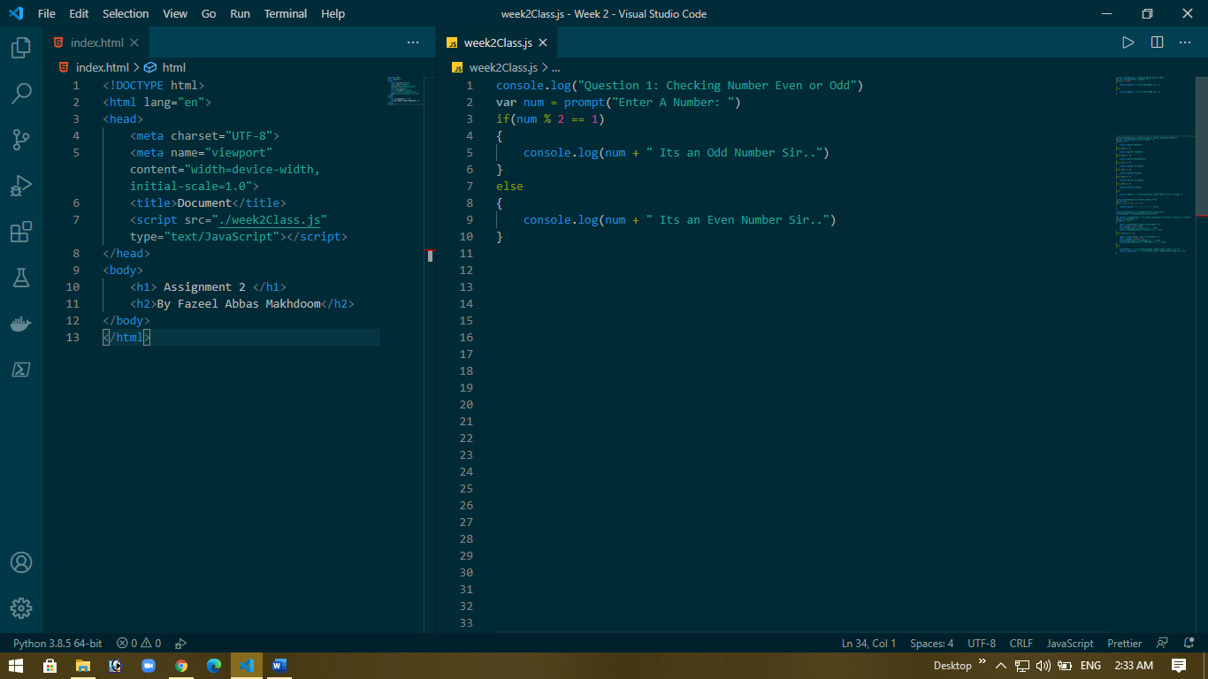

1. Ask user to enter day in numbers, and show user which day it is Like (Monday, Tuesday etc...)

Show error ‘Enter number within range etc…….’ if user enters an invalid number….

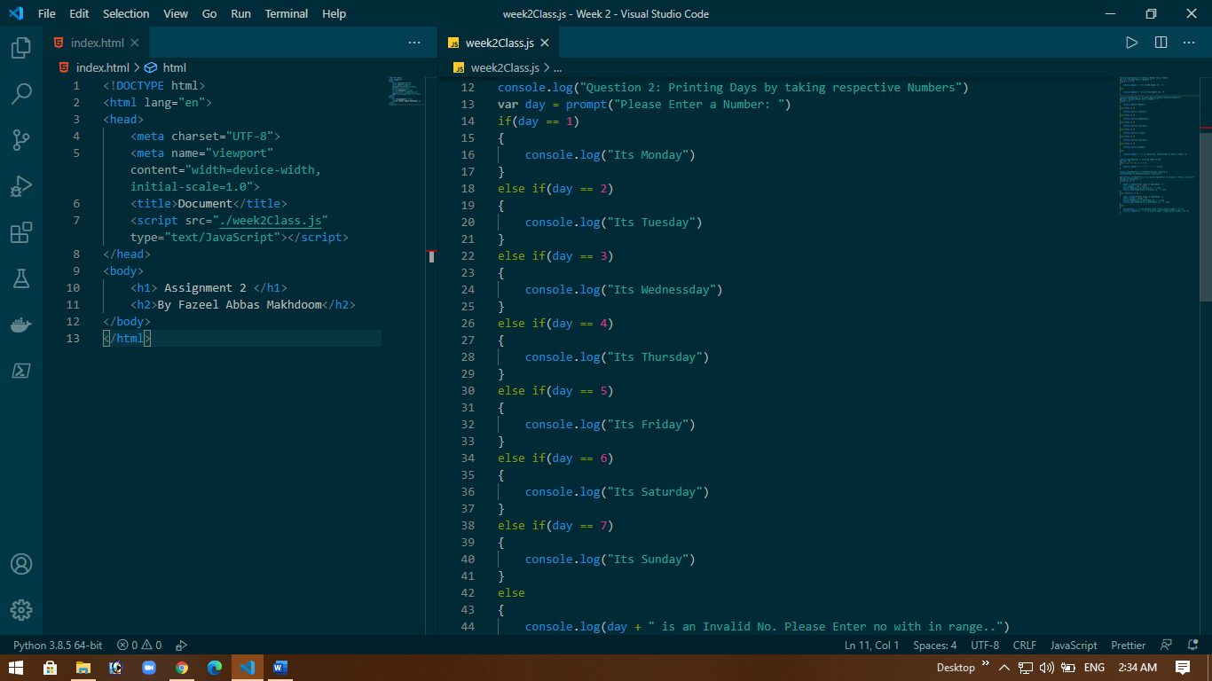

1. What’s the difference between === & == , != & !== ? Just put your theoretical answer below.

**ANS**

**=== are used to check whether the value and data type is same or not while == is used check value only.**

**!= is used as not equal to for a value and !== is to check if both data type and its value is not equal to or not.**

1. Write a table of 9 with proper formatting using for loop ?

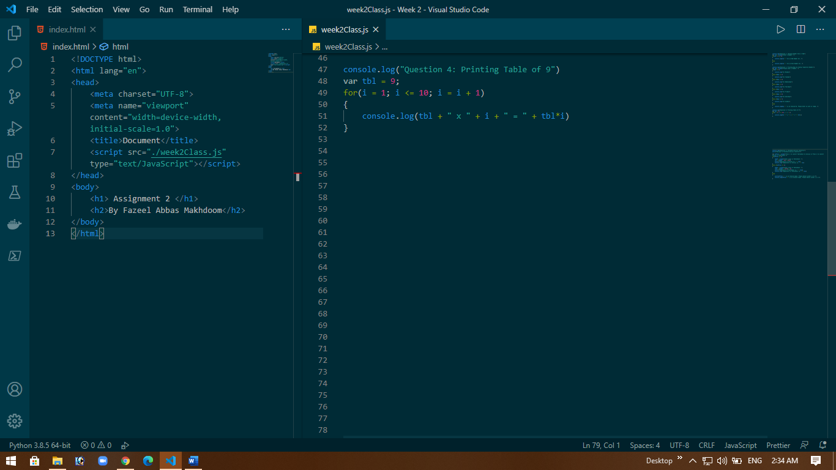

1. Make a program that show user a welcome message ***Welcome To Farenheit/Celcius Convertor.***i) then ask user to select either they want to convert from Fahrenheit to Celsius or celcius to farenhite ?  
   ii) then ask for the conversion number  
   iii) calculate the result & show it in alert

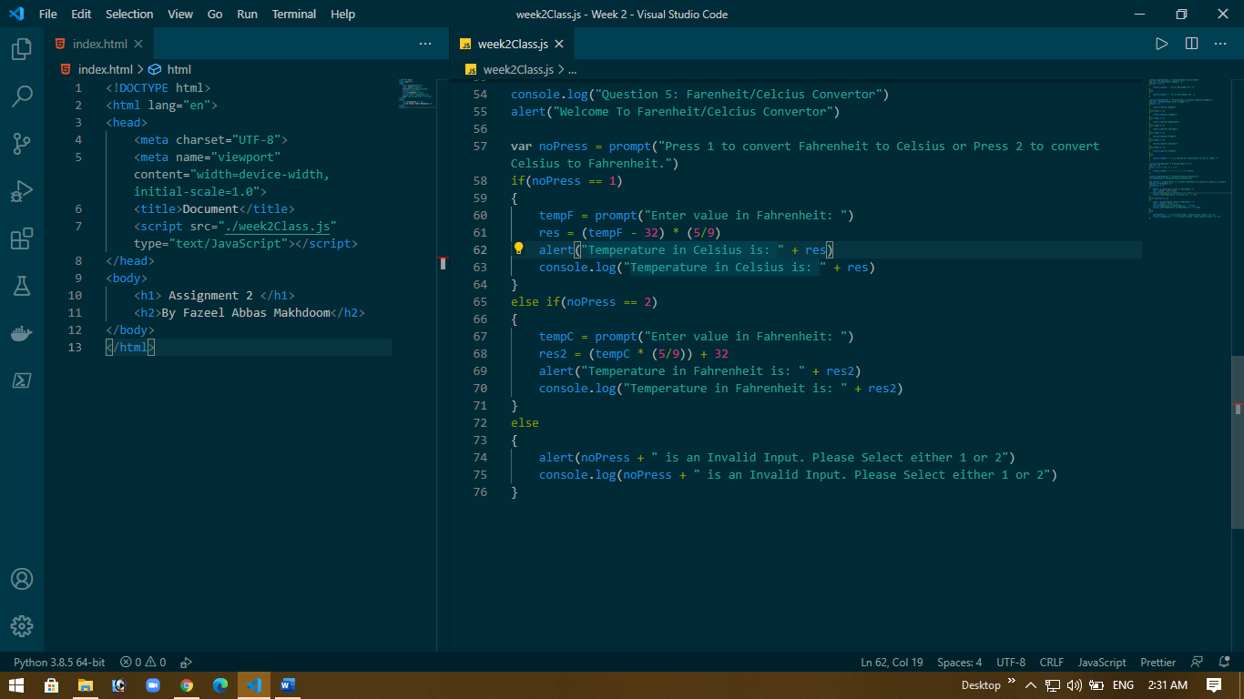

**OUTPUT OF ALL QUESTION**

